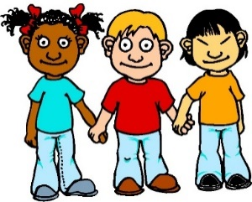 | Getting to Know My Partner: A Chit-Chat Activity  Directions: Ask your new friend these questions and write down what he or she says. Then talk about similarities and differences between your partner’s answers and yours.

Partner’s Name: ____________________________

1. Would you rather have a ride around the world on a magic carpet or one magic wish? | Partner’s answer: _____________________  _______________________________  _______________________________  _______________________________  _______________________________
2. What is the worst thing about being 8 (9 or 10) years old? | Partner’s answer: _____________________  _______________________________  _______________________________  _______________________________  _______________________________
3. What is the one thing that you couldn’t live without? Why couldn’t you live without it? | Partner’s answer: _____________________  _______________________________  _______________________________  _______________________________  _______________________________
4. What is something you would like to learn? What is something you would like to teach someone else to do? | Partner’s answer: _____________________  _______________________________  _______________________________  _______________________________  _______________________________
5. If you had to live inside a TV show for a whole week, which show would you like to be in and why? | Partner’s answer: _____________________  _______________________________  _______________________________  _______________________________  _______________________________
6. If you could have a superpower, what would it be? What would you do with it? | Partner’s answer: _____________________  _______________________________  _______________________________  _______________________________  _______________________________
7. My favorite breakfast is . . .  (fill in the blank) | Partner’s answer: _____________________  _______________________________  _______________________________  _______________________________  _______________________________
8. When I dance I look like . . .  (fill in the blank) | Partner’s answer: _____________________  _______________________________  _______________________________  _______________________________  _______________________________
9. Free Question: This is where you can ask your partner a question . . .  . . . | Partner’s answer: _____________________  _______________________________  _______________________________  _______________________________  _______________________________

