**For the Heroes: A Pep Talk from “Kid President”**

**Grades 3 and 4**

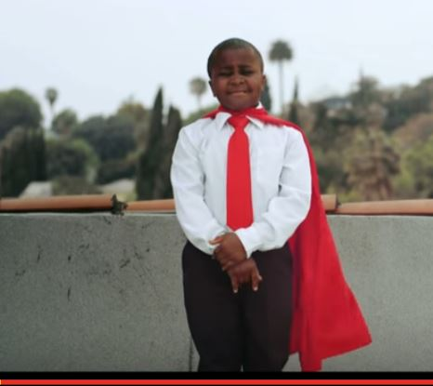

**Goal: To realize the power within oneself to change the world.**

***Prior to your online discussion with your online partner: Click on the link below to watch Kid President’s message. Take notes and discuss with your classmates what Kid President is really saying.***

1. **During your online discussion with your partner:**

Using the notes that you took when you watched the video, discuss Kid President’s message.

1. **After your online chat, write a letter telling your online partner what you heard him/her say during when you discussed the video. The letter could include any lingering questions that the online partners have following the online discussion.**

<https://www.youtube.com/watch?v=tgF1Enrgo2g&list=PLc3fk_nP5UvBiBE2eAoQmzLCIePcD9Hrb&index=3>

Standards addressed: [CCSS.ELA-Literacy.CCRA.R.1](http://www.corestandards.org/ELA-Literacy/CCRA/R/1/) , [CCSS.ELA-Literacy.CCRA.R.2](http://www.corestandards.org/ELA-Literacy/CCRA/R/2/)

[CCSS.ELA-Literacy.CCRA.R.7](http://www.corestandards.org/ELA-Literacy/CCRA/R/7/)

1. What is “Kid President” really saying?

|  |
| --- |
|  |
|  |
|  |

**Kid President gave us a “pep talk.”**

**A “pep talk” is a talk intended to make someone feel more courageous or enthusiastic.** [CCSS.ELA-Literacy.CCRA.R.4](http://www.corestandards.org/ELA-Literacy/CCRA/R/4/)

1. Have you ever given or heard a pep talk? Talk about it with a partner.

Who else do you know who have given pep talks? Teacher? Mom? Dad? Friend? Baseball coach? Gymnastics coach? What did they say?

|  |
| --- |
|  |
|  |
|  |
|  |

1. What was the most important part of the video for you? Why? Cite evidence from the text to support your opinion. If you do not have an answer right away, then watch the video again to see if you can find it.

[CCSS.ELA-Literacy.CCRA.R.1](http://www.corestandards.org/ELA-Literacy/CCRA/R/1/) ; [CCSS.ELA-Literacy.CCRA.R.2](http://www.corestandards.org/ELA-Literacy/CCRA/R/2/)

|  |
| --- |
|  |
|  |
|  |
|  |
|  |

Teacher’s Pages:

Below is the alignment of each question to the CT Core Standards

**Viewing the videos:**

[CCSS.ELA-Literacy.CCRA.R.7](http://www.corestandards.org/ELA-Literacy/CCRA/R/7/) Integrate and evaluate content presented in diverse media and formats, including visually and quantitatively, as well as in words.1

1. What is “Kid President” really saying?

[CCSS.ELA-Literacy.CCRA.R.1](http://www.corestandards.org/ELA-Literacy/CCRA/R/1/) Read closely to determine what the text says explicitly and to make logical inferences from it; cite specific textual evidence when writing or speaking to support conclusions drawn from the text.

[CCSS.ELA-Literacy.CCRA.R.2](http://www.corestandards.org/ELA-Literacy/CCRA/R/2/) Determine central ideas or themes of a text and analyze their development; summarize the key supporting details and ideas.

[CCSS.ELA-Literacy.CCRA.R.7](http://www.corestandards.org/ELA-Literacy/CCRA/R/7/) Integrate and evaluate content presented in diverse media and formats, including visually and quantitatively, as well as in words.

1. **A “pep talk” is a talk intended to make someone feel more courageous or enthusiastic.**

Have you ever given or heard a pep talk? Talk about it with a partner.

Who else do you know who have given pep talks? Teacher? Mom? Dad? Friend? Baseball coach? Gymnastics coach? What were the circumstances?

[CCSS.ELA-Literacy.CCRA.R.4](http://www.corestandards.org/ELA-Literacy/CCRA/R/4/) Interpret words and phrases as they are used in a text, including determining technical, connotative, and figurative meanings, and analyze how specific word choices shape meaning or tone. (pep talk and quote: We are not all of our problems or mistakes)

1. What was the most important part of the video for you? Why? Cite evidence from the text to support your opinion. If you do not have an answer right away, then watch the video again to see if you can find it.

[CCSS.ELA-Literacy.CCRA.R.1](http://www.corestandards.org/ELA-Literacy/CCRA/R/1/) Read closely to determine what the text says explicitly and to make logical inferences from it; cite specific textual evidence when writing or speaking to support conclusions drawn from the text.

[CCSS.ELA-Literacy.CCRA.R.2](http://www.corestandards.org/ELA-Literacy/CCRA/R/2/) Determine central ideas or themes of a text and analyze their development; summarize the key supporting details and ideas.