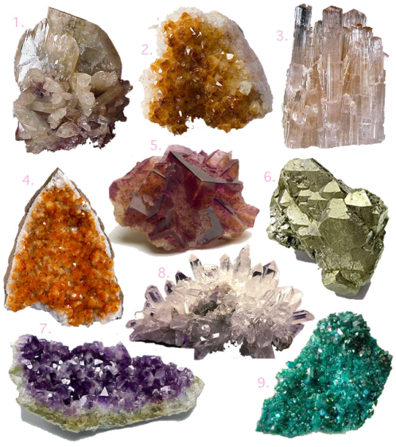
Lesson 1 - Rocks and Minerals
Rocks and Minerals STEM Activity Student Activity

Watch the video: https://www.youtube.com/watch?v=CmCHSj2wTCI
Graphite is the perfect mineral to use in pencils because of low hardness and dark streak. It easily rubs off on paper and creates a dark mark.

Your challenge is to choose a mineral and decide a real life application for it. Research your mineral online with your partners and brainstorm ideas for what kinds of things you would use this mineral to build. Create a list of ideas together. Discuss with your partners why you think this mineral is the best for this design. Think about the different properties of minerals you have learned about during your unit. Some minerals are used for things like building, floors, countertops, jewelry or even signs in front of your schools.

Prior to meeting again, create a blueprint with your in-school partner for your design. A blueprint is a labeled drawing that engineers use when they are planning to build something. When you meet again share your blueprints with your partners from the other school. Discuss what the best features of each blueprint has and redesign your idea for your product. In your science notebook, create your final blueprint. Tell why you chose the mineral or minerals you decided to use for this product. Answer the following questions together and write your answers in your science notebooks. If you were going to build a building which mineral would you chose and why? Now answer the same question for each of the following: a countertop, a piece of jewelry or a sign for outside of your school.

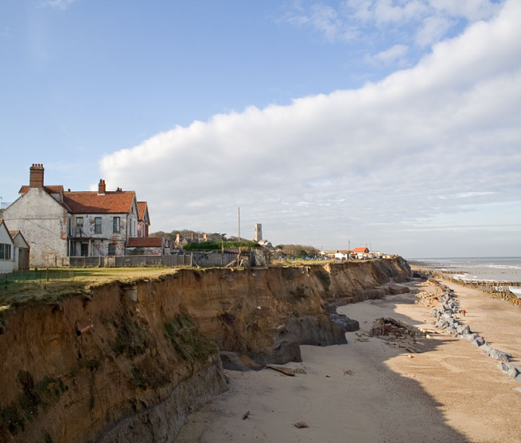
Lesson 2 - Erosion
Erosion STEM Activity Student Activity

Watch the video: https://www.youtube.com/watch?v=OgcX5L_6E-E

Discuss with your group, “How can you reduce the effects of erosion?” and “What different variables might affect erosion rate?”

Session 1
Using a large tray filled with dirt, sand, and or rocks, test different variables of erosion and observe their effects on erosion rate. Variables may include: angle of the slope, speed of water flow, or different rock types. You may test more than one variable. Be sure to collect data during this process.

Session 2
Observe the following image:
https://upload.wikimedia.org/wikipedia/commons/d/d6/Happisburgh_and_eroding_cliffs_-_geograph.org.uk_-_76825.jpg

You and your group are engineering specialists for the US Army Corps of Engineers and have been asked to help solve a problem. The cliff in the photo is eroding too quickly and may soon affect the lighthouse or buildings nearby. You need to brainstorm some possible solutions in your science notebook to slow the rate of erosion.

After brainstorming, design a solution using scientific diagrams and labels to describe your thinking. Be sure to use pictures and words to explain your thinking. You will share your design with another group who can provide you with feedback on your design. Use that feedback to redesign and improve your design. You will share your final design using paper or digital resources.

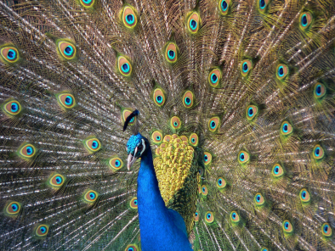
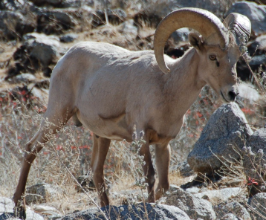
Lesson 3 - Adaptations
Adaptation STEM Activity Student Activity

Watch the video - https://www.youtube.com/watch?v=Y_Ps9XqqrDI
After watching the video, develop a list of questions that a zoologist must research about an organism to ensure that the organism will survive well before it arrives at your zoo/aquarium. Research an organism of your choosing (https://a-z-animals.com/) and answer the questions that you developed in your science notebook.

In your science notebook, design an enclosure that would meet the needs of your organism. Be sure to label parts of your enclosure and describe how they help your organism survive better. Be sure to be as specific as possible when labeling materials in your enclosure. After an initial design, pair up with your in-class partner and provide feedback. Use that feedback to redesign any parts of your enclosure that would improve your organism’s chances of survival.

Using paper (or a digital drawing resource), create a zoo sign for your enclosure. On the sign, you should provide details for zoo guests describing the needs of your organism and how they are being met.

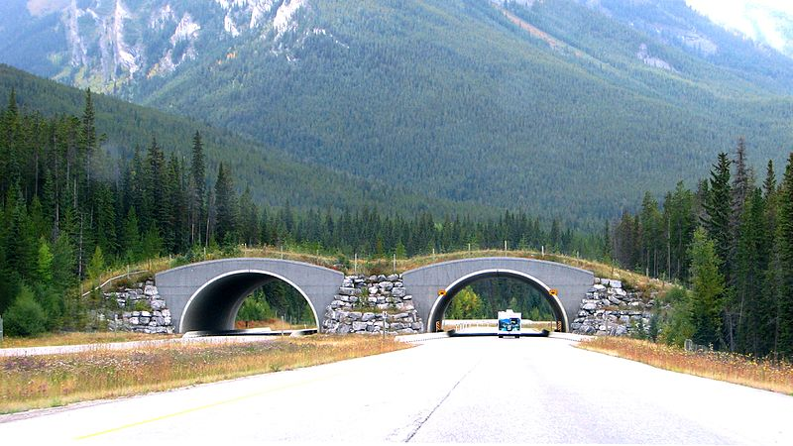
Lesson 4 - Environment Change
Environment Change STEM Activity Student Activity

Watch the video: https://www.youtube.com/watch?v=U6lWv8enIAw
After watching the video think about how organisms may deal with changes to their environment. Many become endangered due to these changes. Today you will design a solution to a problem caused when an organism's environment changes. You may choose one of the following situations, or research one of your own at https://www.worldwildlife.org/species/directory

Sea lions try to rest on fishing boats while out at sea. This sometimes results in the boats tipping. Fishermen have begun to place barb wire around the boat to stop them, but this injures or kills the sea lions. | Cats, rats, dogs, and pigs have recently been introduced to the marine iguana's habitat. These animals prey on the iguana. | Manatees swim in shallow warm water. The increase in boat traffic has caused many manatees to be hit by boats or propellers from boats.

Brainstorm ideas for how you can design a solution for an organism. Design your solution in your science notebook. Be sure to include pictures and labels.

Get together with your in-class partner and provide feedback on their design while they provide you with feedback. Use the feedback to make decisions on how you can redesign your idea to provide a better solution.

After final designs are complete, you will share out your ideas. You may use paper or digital resources for your final design. While other students present, you should provide feedback about the merit of their solution ideas.

Attributes

Rocks and Minerals: By SemiletovaOlga (Own work) [CC BY-SA 4.0 (http://creativecommons.org/licenses/by-sa/4.0)], via Wikimedia Commons

Coastal erosion of sea cliffs at Happisburgh, Norfolk UK. Photograph © Andrew Dunn, 04 November 2006. Website: http://www.andrewdunnphoto.com/

Bighorn sheep Andrew Barna [CC BY-SA 3.0 (http://creativecommons.org/licenses/by-sa/3.0)], via Wikimedia Commons
An Indian peacock's train in full display BS Thurner Hof - Photo taken by user BS Thurner Hof CC BY-SA 3.0
Animal overpass Yoshio Kohara [CC BY 3.0 (http://creativecommons.org/licenses/by/3.0)], via Wikimedia Commons

