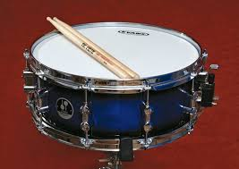

Lesson 1 - Sound Stations
Sound Centers STEM Activity Student Activity
This lesson consists of different stations, each of which will contain different examples of sound. While you rotate through the stations, be sure to bring your science notebook. At each station, you will label your notebook with the station number, and create a T-chart with the labels I Notice on one side, and I Wonder on the other.

Station 1 - Video Station
Watch the following videos. While watching the videos, be sure to take notes describing your noticings and wonderings in your T-chart.
- Glass Singing - https://www.youtube.com/watch?v=ULiNR-k4m70
- Thunder Drum - https://www.youtube.com/watch?v=3MSh6i7IH1g
- Voice Shattering Glass - https://www.youtube.com/watch?v=10lWpHyN0Ok
Choose one of the videos. On the next page of your science notebook, create a visual explaining how sound waves traveled in the video. Use pictures and labels to explain your thinking.

Station 2 - DIY Guitar
Stretch out different sized rubber bands between the nails. Pluck the rubber bands and write down what you notice and wonder in your T-chart.
On the next page, use pictures and words to explain how different sized rubber bands affected the sound that was produced. Include your ideas about what caused those changes.

Station 3 - Drum and Paper Clips
Place the paper clips on the drum. Hit the drum several times (both hard and soft). Take notes describing your noticings and wonderings in your T-chart.
On the next page, use pictures and words to explain how sound is produced in a drum.

Station 4 - Bottle Pitch (Safety Note: Glass bottles will break if you do not take care of them. Do NOT place them near the edge of a table. Do NOT strike them hard during the experiment.)
Tap the different bottles with a spoon. Take notes in your T-chart about what you wonder and notice about the variety of sounds being produced by the different bottles.
On the next page, use pictures and words to explain how the sounds of the bottles changed. Include your ideas about what caused those changes.


Lesson 2 - Sound Design

Sound Design STEM Activity Student Activity

After viewing the Sydney Opera House https://upload.wikimedia.org/wikipedia/commons/4/40/Sydney_Opera_House_Sails.jpg and Grand Central Station https://www.youtube.com/watch?v=yUUAG3hIYGg, you have an idea that different materials and shaped can change the distance that sound waves can travel. Read the following problems:

- You are at a family gathering and want to play music. Your speaker is not very loud. What can you do to make the sound louder?

- Your brother is practicing his recorder in his room, but you are trying to read next door. What can you do to eliminate the sound?

Choose one problem that you and your group would like to solve. Use the materials provided to test the effects of different materials on the volume of sound. Investigate which materials increase or decrease the distance that sound travels.

After you have decided which materials would best help you solve your problem in the scenario, design a solution for that problem in your science notebook. Be sure to include labels in your diagrams stating which materials you used. Also, provide a visual representation of how waves would move through your design.

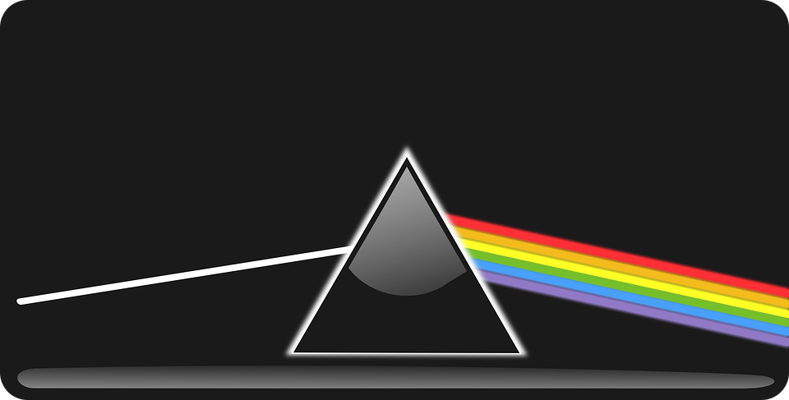
Lesson 3 - Light Stations
Light Centers STEM Activity Student Activity

Watch the video https://www.youtube.com/watch?v=I0OPNOpU6SY
This lesson consists of different stations, each of which will contain different examples of light. While you rotate through the stations, be sure to bring your science notebook. At each station, you will label your notebook with the station number, and create a T-chart with the labels I Notice on one side, and I Wonder on the other.

Station 1 - Bending Light
Place a pencil in the cup of water. Observe the appearance of the pencil. In your science notebook, answer the questions in your T-Chart: What do you notice? What do you wonder? On a separate page, draw a diagram representing what you observed in the cup. Using words/labels, share your ideas about what is happening in the cup.

Station 2 - Absorbing and Reflecting
In this station, you will test how different objects react to light. Shine the light against the different objects provided and observe the path of the light. In your science notebook, answer the questions in your T-Chart: What do you notice? What do you wonder? On a separate page, draw a diagram representing what you observe about how different materials reflect or absorb light. Be sure to include the path of the light in your diagram. Use both words and pictures to explain your thinking.

Station 3 - Transparent, Translucent, and Opaque
In this station, you will test how light travels through certain objects. Shine the light against the different objects provided and observe the path of the light. In your science notebook, answer the questions in your T-Chart: What do you notice? What do you wonder? On a separate page, draw a diagram representing what you observe about how light travels through objects. Be sure to include the path of the light in your diagram. Use both words and pictures to explain your thinking.

Station 4 - Mixing Light
In this station, you will observe how colored light react with each other. Shine each individual light against a white paper background. Then start to mix different combinations of the colored lights. In your science notebook, answer the questions in your T-Chart: What do you notice? What do you wonder? On a separate page, draw a diagram representing what you observe about how the colors react with each other. Use both words and pictures to explain your thinking.

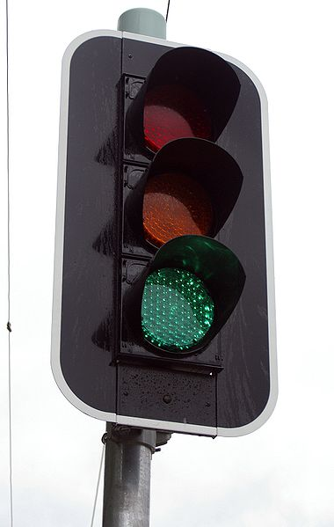
Lesson 4 - Light Design

Light Design STEM Activity Student Activity
Watch the following videos:
Light House - https://www.youtube.com/watch?v=XmBi1XeiqGg
Morse Code Video - https://www.youtube.com/watch?v=L6gxfX4GrbI

Think about different innovations that use light or sound to communicate. Your task is to communicate with an individual who is a long distance away. To do this, you will develop a system using light or sound to transmit information.

Your teacher will give you a list of several commands. You will have to communicate one of these with a person who is far away, but you will not know which message you will use until the day of testing.
With your partners, brainstorm ideas about how light and and sound can travel over a long distance. Think about materials that would help your signal go farther.

Design a device in your notebooks that use light of sound to solve the problem of communicating over long distances. Be sure to label your materials and show the path of sound/light. Also, create a system you will use so people will understand your message (Think back to the morse code video. Each letter had a different sound to represent it.)

Get together with another group of students. Provide feedback for their design while they do the same. Use that feedback to redesign, or make adjustments, to your design. Once you have a final design, start to build it.

When the designs are built, you will have an opportunity to test your design with another group. Again, use feedback from this test to make adjustments.

On the final day, you will be given the task to send a message to a mystery guest. You may provide the guest with information about your system before the trial (for example a key describing what different sounds/lights mean). Your teacher will tell you the message you will communicate after the guest is a far distance away. The mystery guest will try to guess your message and provide feedback about the effectiveness of your design.

Attributes

Drum: By Vladimir Morozov from Russia (snare drum) [CC BY 2.0] (http://creativecommons.org/licenses/by/2.0)], via Wikimedia Commons

Traffic Light: By Bidgee (Own work) [CC BY 3.0 (http://creativecommons.org/licenses/by/3.0)], via Wikimedia Commons

