<https://www.youtube.com/watch?v=KIXfSeofZAE>

My Badger is a Bully – GRADE 3

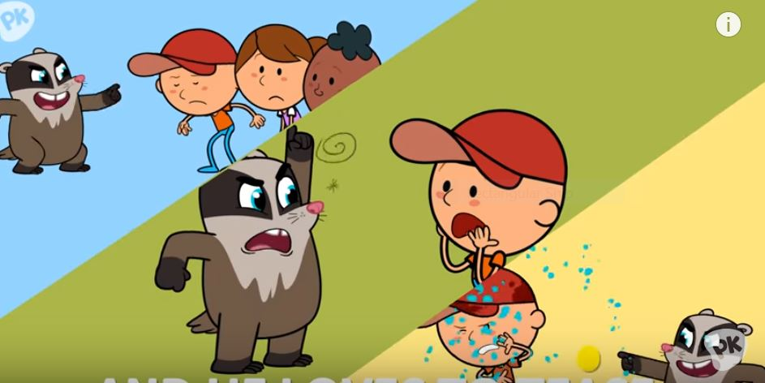

**Goal:** ELA: Focus on Standard 4: Interpret words and phrases as they are used in a text, including determining technical, connotative, and figurative meanings, and analyze how specific word choices shape meaning or tone.

**Social Emotional:** What can we do about the “badgers” in our lives?

As you watch the video, follow along with the words.

|  |  |
| --- | --- |
| My badger is a bully  My badger is a bully  He’s pushy pushy shovey everyday  My badger is a bully  He’s nothing but a bully  I don’t like the things that he will say  All day, he was being mean  Laughing acting bad  He name calls  And he loves to tease  This made me so mad  My badger is a bully  My badger is a bully  He’s pushy pushy shovey everyday  My badger is a bully  He’s nothing but a bully  I don’t like the things that he will say  I= was playing in the park  With a friend or two  He came, tried to push me down  And he stole our shoe | My badger is a bully  My badger is a bully  He’s pushy pushy shovey everyday  My badger is a bully  He’s nothing but a bully  I don’t like the things that he will say  One day he came to me for help  He got pushed around  I knew exactly how he felt  I helped him off the ground  My badger’s not a bully,  No, he’s not a bully  He’s not pushy anymore  My badger’s not a bully  He’s better than a bully  He’s really learned his lesson that’s for sure  He can be my friend  Once more….. |

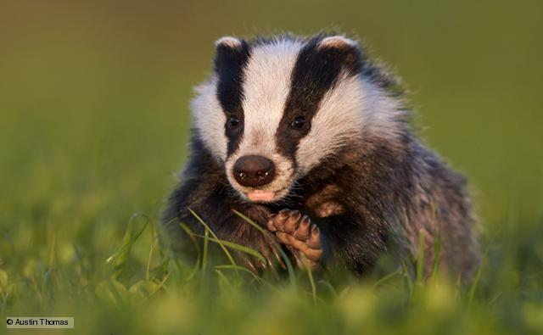

**Definition of a badger**: a heavily built omnivorous nocturnal mammal of the weasel family, typically having a gray and black coat.

To ask (someone) over and over for something; pester.

Timmy **badgered** his teacher about going out for recess even though it was pouring.

|  |  |
| --- | --- |
| *synonyms:* | [pester](https://www.google.com/search?espv=2&biw=1024&bih=492&q=define+pester&forcedict=pester&sa=X&ved=0ahUKEwjS7fTxwdbRAhVJ6YMKHeAkBsYQ_SoIIDAA),  [bother](https://www.google.com/search?espv=2&biw=1024&bih=492&q=define+bother&forcedict=bother&sa=X&ved=0ahUKEwjS7fTxwdbRAhVJ6YMKHeAkBsYQ_SoIIjAA), [plague](https://www.google.com/search?espv=2&biw=1024&bih=492&q=define+plague&forcedict=plague&sa=X&ved=0ahUKEwjS7fTxwdbRAhVJ6YMKHeAkBsYQ_SoIIzAA), [torment](https://www.google.com/search?espv=2&biw=1024&bih=492&q=define+torment&forcedict=torment&sa=X&ved=0ahUKEwjS7fTxwdbRAhVJ6YMKHeAkBsYQ_SoIJDAA), [hound](https://www.google.com/search?espv=2&biw=1024&bih=492&q=define+hound&forcedict=hound&sa=X&ved=0ahUKEwjS7fTxwdbRAhVJ6YMKHeAkBsYQ_SoIJTAA), [nag](https://www.google.com/search?espv=2&biw=1024&bih=492&q=define+nag&forcedict=nag&sa=X&ved=0ahUKEwjS7fTxwdbRAhVJ6YMKHeAkBsYQ_SoIJjAA),  [tease](https://www.google.com/search?espv=2&biw=1024&bih=492&q=define+tease&forcedict=tease&sa=X&ved=0ahUKEwjS7fTxwdbRAhVJ6YMKHeAkBsYQ_SoIKDAA), |

After watching the video, discuss the following:

1. Why do you think the name of the song is My Badger is a Bully?

Hint: Review the definition of badger. The name of the song and the definition of *badger* are related. [CCSS.ELA-Literacy.CCRA.R.4](http://www.corestandards.org/ELA-Literacy/CCRA/R/4/)

|  |
| --- |
|  |
|  |
|  |
|  |

1. Do you know someone in real life who you think is a badger? (someone who bothers you a lot?). Why is this person a badger? What evidence from the definition supports your claim? What can you do about it? Talk about the solution to this problem with a partner and write down your answer. Use the word *badger* in your answer to demonstrate your understanding of the meaning of the word.

[CCSS.ELA-Literacy.CCRA.R.4](http://www.corestandards.org/ELA-Literacy/CCRA/R/4/)

|  |
| --- |
|  |
|  |
|  |

To the teacher:

[CCSS.ELA-Literacy.CCRA.R.4](http://www.corestandards.org/ELA-Literacy/CCRA/R/4/) Interpret words and phrases as they are used in a text, including determining technical, connotative, and figurative meanings, and analyze how specific word choices shape meaning or tone.